Guidelines
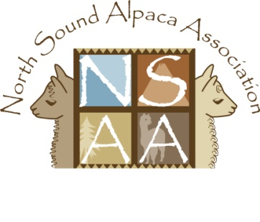
for Classified Advertisements
on NSAA’s Website

Information will be uploaded to the website once a month. Please submit your info by the 5th of the month for updates done on or around the 10th. Updates received after the 10th will be uploaded the following month.

- Advertisements will be limited to 75 words.

- Photos optional (but encouraged to make your ad more eye-catching). Submit photos in JPG, GIF, or PNG format - size no larger than 5 MB each.

- Please help keep the website current and up-to-date. Contact webmaster by 1st of the month to keep your ad posted. Ads not renewed by 5th of the month will be removed. Please limit ads to one ad per category, per farm, per month (for a combined limit of 4 ads per farm per month).

- Ad can be used for any item for sale/trade, any service offered, or any want ads; however, the NSAA Board reserves the right to refuse any ad and/or photo deemed inappropriate.

- 2012 Pricing:
FREE - NSAA Farm Members (up to 4 ads at a time)
$5.00 (per ad) - NSAA Associate Members (up to 4 ads at a time)
Open to other farms, individuals or businesses (Pricing to be determined).

Payment can be made via PayPal on the NSAA website, or by check payable to NSAA and mailed to PO Box 1131, Stanwood, WA 98292.

Email your ad to webmaster@northsoundalpacas.org

The following form can be used to place your ad, or simply send an email including the information requested on the form.

Guidelines
for Classified Advertisements
on NSAA’s Website

Please provide the following information for your classified advertisement on NSAA’s website…
CONTACT information:
Farm Name
Email address
Phone

CATEGORY: (check one)
For Sale or Trade
Wanted
Service Offered
Services Wanted
Other / Misc / Events / Etc.

ADVERTISING TEXT: Use the space below to enter your ad copy. Please limit to 75 words.

PAYMENT:
No payment due - NSAA Farm Member
$5 NSAA Associate - will be paid via PayPal on the website
$5 NSAA Associate - will be paid by check & mailed to NSAA - PO Box 1131, Stanwood, WA 98292

Please provide the above information for each submission. You are entitled to ONE ad per category at a time (limit of 4 ads total at one time).
Your advertising info and photo can be emailed to webmaster@northsoundalpacas.org .
Visit the website at www.northsoundalpacas.org/classifiedads to view Classified Ads.

